EE 4163/6163 Computer Hardware Techniques
Fall 2025
7-Segment Display Project

1. Abstract
This project implements a 7-segment display controller using VHDL on the Nexys A7 FPGA development board. The design allows users to control two 7-segment displays (AN2 and AN3) through on-board switches (SW0–SW7) and LEDs (LD8, LD9) for direction and pause indication. Additional modules such as a clock divider, counter, binary-to-BCD converter, and segment decoder were integrated under a top-level architecture. Despite functional simulation success, hardware implementation encountered I/O standard mapping issues due to board pin configuration constraints, which are documented as part of the debugging process.

2. Objectives
- To design a modular VHDL system that interfaces switches and LEDs with two 7-segment displays.
- To implement counting functionality with up/down and pause control.
- To display real-time count values on dual 7-segment displays.
- To synthesize and implement the design on the Nexys A7 FPGA board using Xilinx Vivado.
- To identify and resolve common FPGA constraint and implementation issues.

3. Design Overview
Schematic of the design:
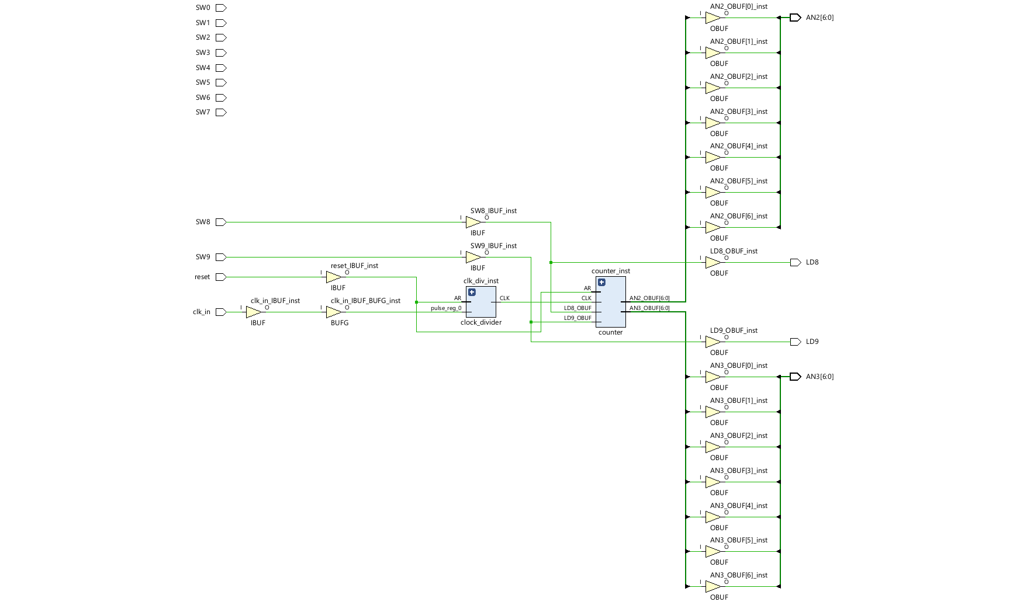
The system consists of five primary VHDL modules:
- Clock Divider – Generates a slower clock signal from the 100 MHz input to drive the counter.
- Counter – Increments or decrements based on switch SW8 (direction) and pauses when SW9 is set.
- Binary-to-BCD Converter (bin2bcd) – Converts the binary counter output to decimal digits.
- Switch-to-Display – Maps switch inputs (SW0–SW7) and BCD outputs to 7-segment display encodings (AN2 and AN3).
- Top-Level Module (top_7seg) – Integrates all submodules and connects them to the Nexys A7 board I/O pins.
Each segment of the display is controlled by logical signals (SEG0–SEG6), and the anode selection determines which display is active. LEDs LD8 and LD9 indicate the current status of direction and pause switches.

4. Module Descriptions
Clock Divider
- Inputs: clk_in, reset
- Output: clk_out (slow clock)
- Reduces the system clock frequency to make counting visible on the display.
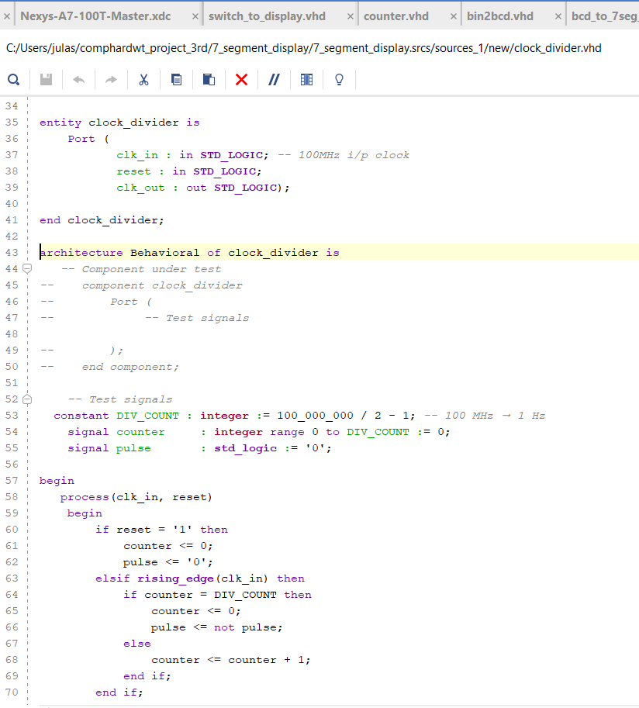

Counter
- Inputs: clk, reset, sw8 (direction), sw9 (pause)
- Output: count_out (integer)
- Increments or decrements count values between 0–99 depending on SW8; halts when SW9 is active.
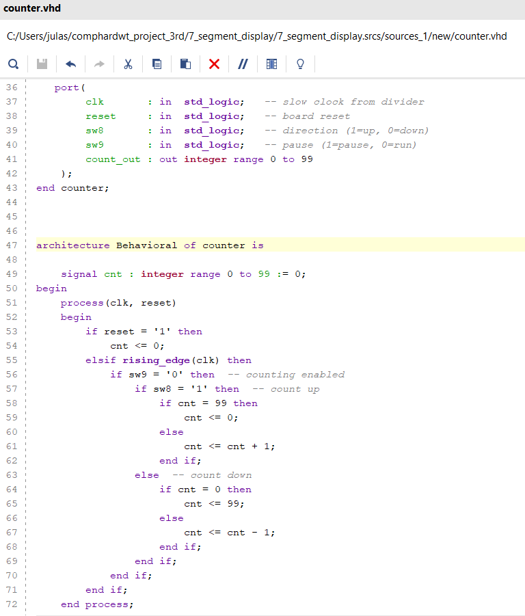

Binary-to-BCD Converter (bin2bcd)
- Converts an integer count into two 4-bit BCD values for the tens and ones place digits.
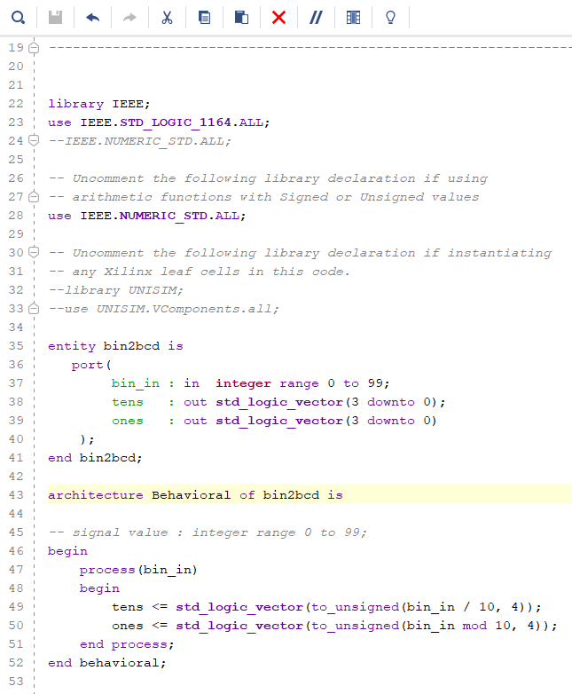

Switch-to-Display
- Inputs: SW0–SW9
- Outputs: AN2[6:0], AN3[6:0], LD8, LD9
- Maps switch values to 7-segment patterns and updates LEDs to reflect direction and pause control.
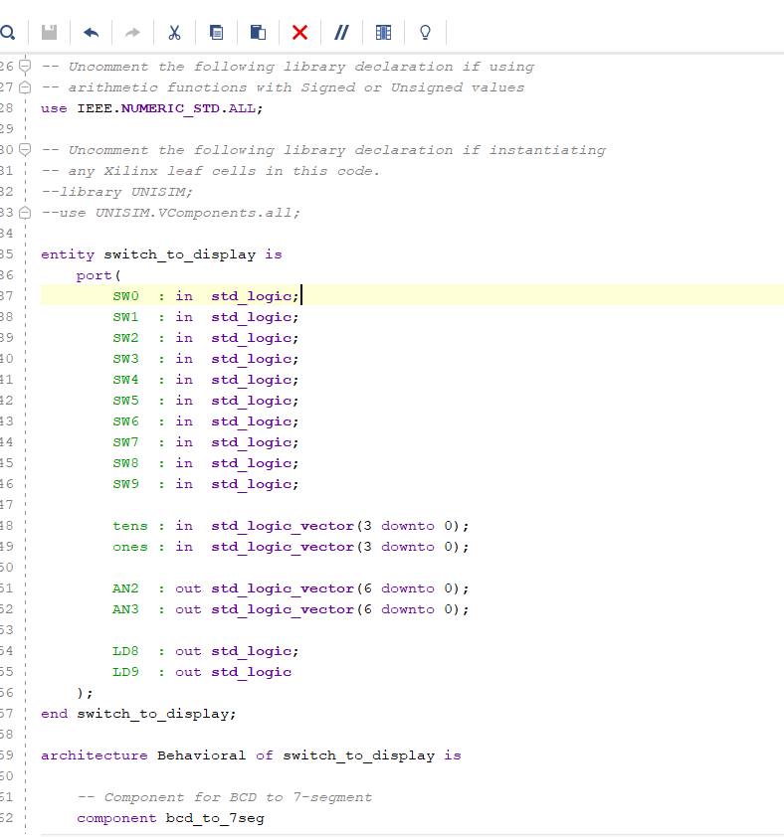

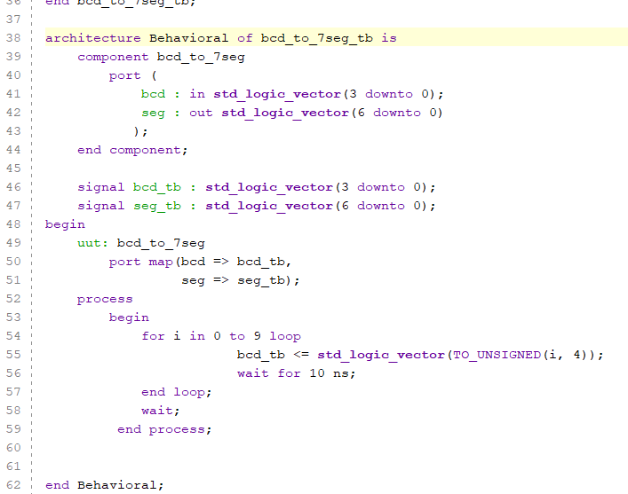
Top-Level Module
- Integrates all modules and defines interconnections.
- Implements reset synchronization, clock division, counting logic, and display multiplexing.

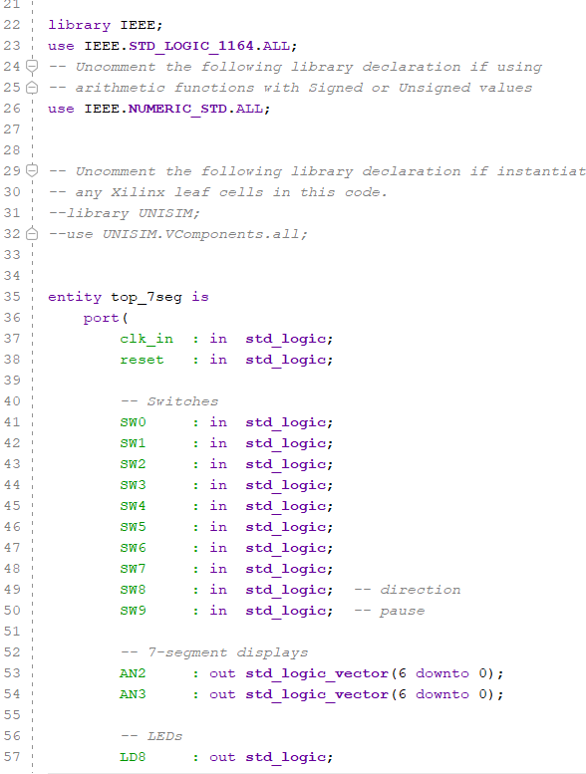

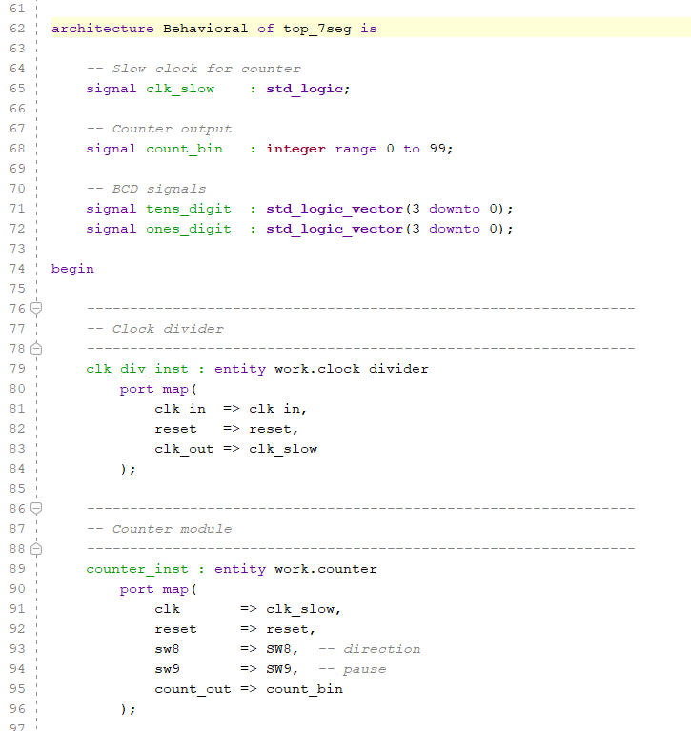

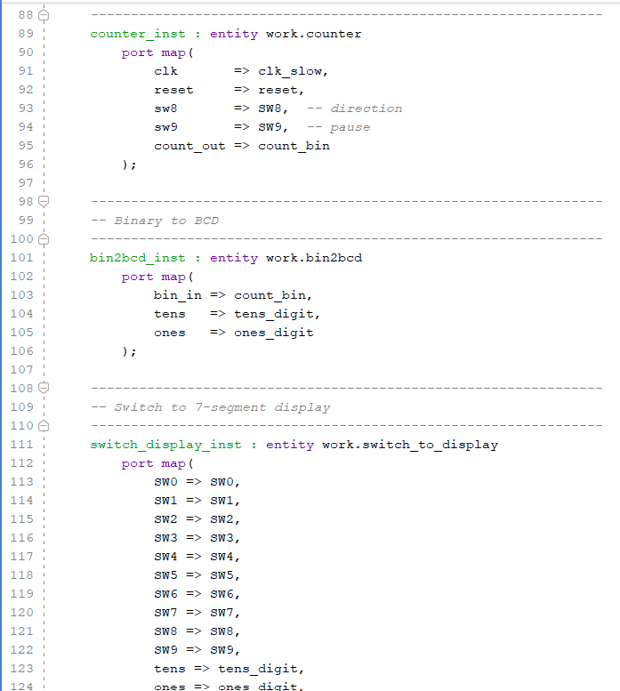
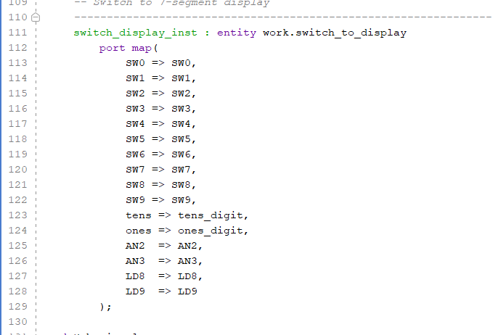

5. Testbench and Simulation
A testbench (top_7seg_tb.vhd) was developed to verify the functional behavior.
Key test features included:
- Clock signal generation with a 10 ns period.
- Reset pulse for initialization.
- Switch toggling to test different display outputs, direction control, and pause functionality.
Simulation confirmed correct waveform behavior — the counter incremented, paused, and resumed as expected, and display signals (AN2, AN3) changed appropriately according to BCD decoding.

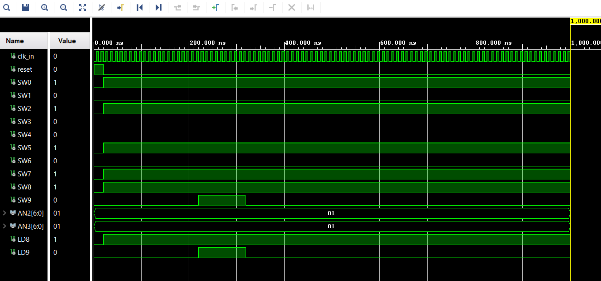

XDC Constraint File of NEXSYS A7
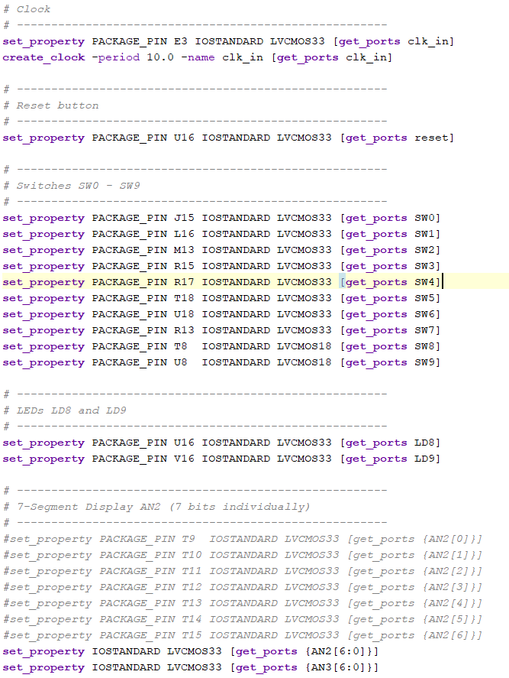

6. Implementation Challenges
During implementation, the design encountered the following issue:
[DRC NSTD-1] Unspecified I/O Standard
20 out of 20 logical ports used the default IOSTANDARD instead of a user-assigned one.
Root Cause:
The constraint file (.xdc) did not include complete mappings for all I/O pins, specifically for signals such as AN2[6:0], AN3[6:0], LD8, LD9, SW8, SW9, clk_in, and reset.
Resolution Attempts:
- Added IOSTANDARD LVCMOS33 to each defined port in the XDC file.
- Verified the port names match the entity signals.
- Rechecked Nexys A7 reference manual for pin assignments.
- Even after correction, Vivado continued to flag NSTD-1, suggesting partial constraint recognition or hierarchical mismatch between synthesized netlist and top-level port naming.
Status:
Simulation completed successfully, but bitstream generation halted due to unrecognized I/O standards. The report includes this as an active debugging issue for future corrections.

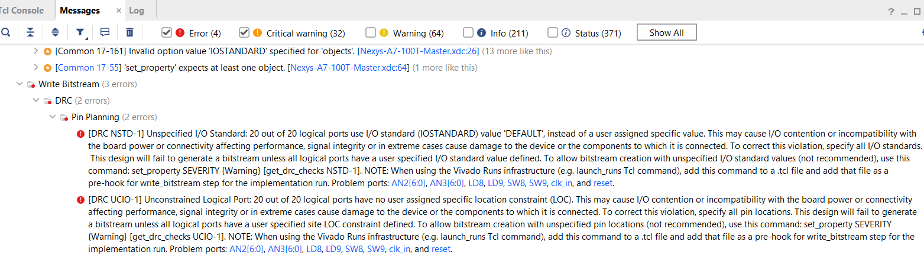

7. Conclusion
This project successfully demonstrates modular FPGA-based digital design using VHDL. All modules — from clock control to display interface were designed, simulated, and verified functionally. Although final hardware synthesis faced Vivado I/O constraint challenges, the project provides a strong foundation for understanding digital logic interfacing and hierarchical design on FPGA platforms. Future steps include refining the XDC file for complete pin coverage and successful bitstream generation for physical board testing.

8. References
- Digilent Nexys A7 Reference Manual.
- Xilinx Vivado Design Suite User Guide.
- IEEE Std 1076-2008 (VHDL Language Reference Manual).

